DAY 1

-- Table: Category

CREATE TABLE Category (

CategoryID INT PRIMARY KEY,

CategoryName VARCHAR(50) NOT NULL

);

-- Table: Publisher

CREATE TABLE Publisher (

PublisherID INT PRIMARY KEY,

PublisherName VARCHAR(100) NOT NULL,

Address VARCHAR(255)

);

-- Table: Book

CREATE TABLE Book (

BookID INT PRIMARY KEY,

Title VARCHAR(150) NOT NULL,

Author VARCHAR(100),

ISBN VARCHAR(13) UNIQUE,

CategoryID INT,

PublisherID INT,

FOREIGN KEY (CategoryID) REFERENCES Category(CategoryID),

FOREIGN KEY (PublisherID) REFERENCES Publisher(PublisherID)

);

-- Table: Member

CREATE TABLE Member (

MemberID INT PRIMARY KEY,

MemberName VARCHAR(100) NOT NULL,

Email VARCHAR(100) UNIQUE,

Phone VARCHAR(15),

JoinDate DATE

);

-- Table: Librarian

CREATE TABLE Librarian (

LibrarianID INT PRIMARY KEY,

LibrarianName VARCHAR(100) NOT NULL,

Email VARCHAR(100) UNIQUE

);

-- Table: Loan

CREATE TABLE Loan (

LoanID INT PRIMARY KEY,

BookID INT,

MemberID INT,

LibrarianID INT,

LoanDate DATE NOT NULL,

DueDate DATE NOT NULL,

ReturnDate DATE,

FOREIGN KEY (BookID) REFERENCES Book(BookID),

FOREIGN KEY (MemberID) REFERENCES Member(MemberID),

FOREIGN KEY (LibrarianID) REFERENCES Librarian(LibrarianID)

);

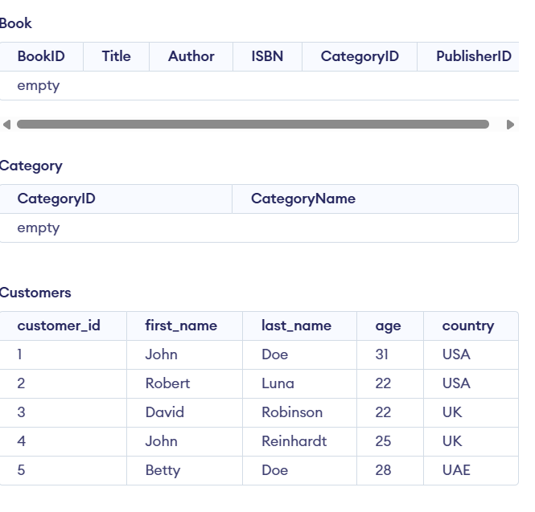

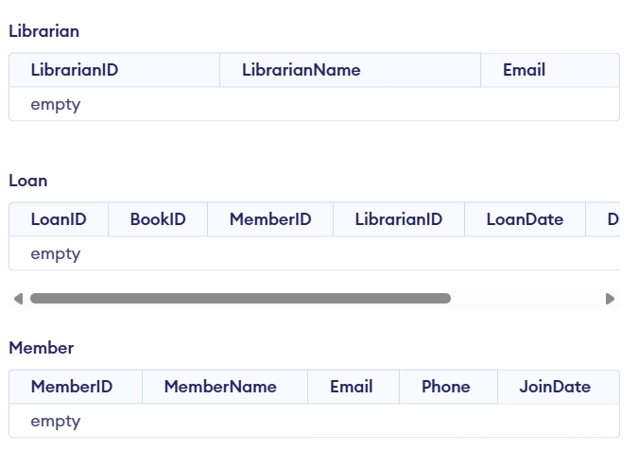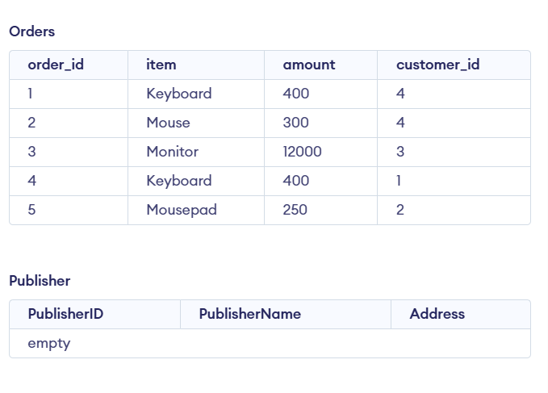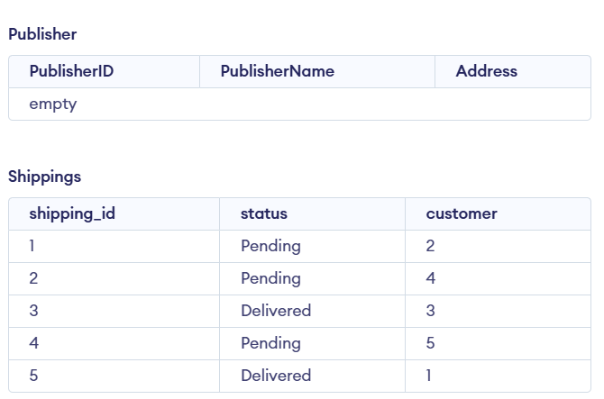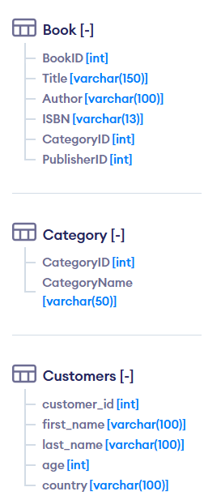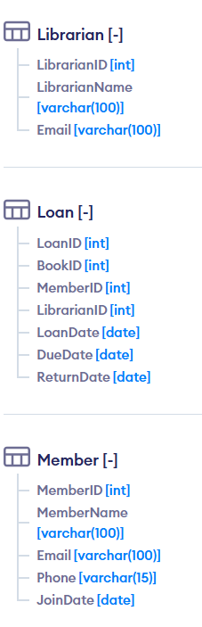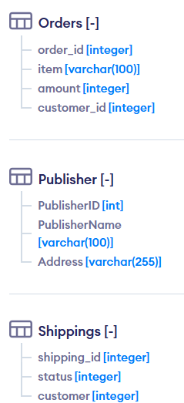

**Identify Entities and Relationships**

**Entities:**

* Book
* Member
* Librarian
* Loan (relationship between Book and Member)
* Category (to classify books)
* Publisher

**Relationships:**

* A **Book** belongs to one **Category** and one **Publisher**.
* A **Member** can borrow many **Books** (via **Loan**).
* A **Loan** involves one **Book** and one **Member**.
* A **Librarian** manages the **Loans**.

Define primary and foreign keys

| **Table** | **Primary Key** |
| --- | --- |
| Category | CategoryID |
| Publisher | PublisherID |
| Book | BookID |
| Member | MemberID |
| Librarian | LibrarianID |
| Loan | LoanID |

| **Table (with FK)** | **Foreign Key** | **References Table** | **References Column** |
| --- | --- | --- | --- |
| Book | CategoryID | Category | CategoryID |
| Book | PublisherID | Publisher | PublisherID |
| Loan | BookID | Book | BookID |
| Loan | MemberID | Member | MemberID |
| Loan | LibrarianID | Librarian | LibrarianID |